Tugas Pemrograman Mobile Pertemuan ke-6.

**Hasil develop aplikasi**

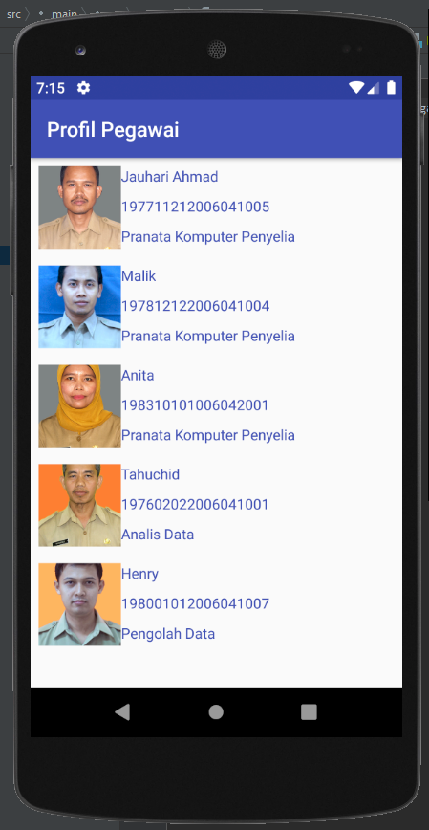

Screenshot halaman utama

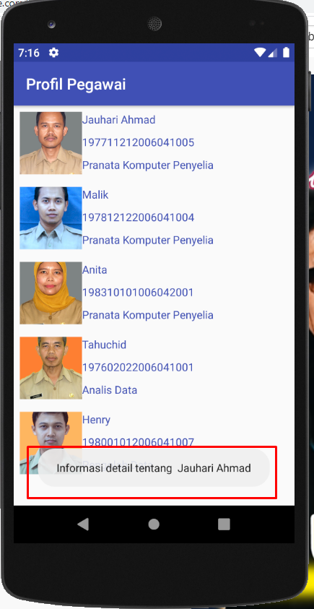

Klik pada nama pegawai

**Source Code**

Pegawai.kt

package com.jauhari.androidrecyclerview.domain  
  
data class Pegawai(  
 val name: String,  
 val image: String,  
 val nip: String,  
 val jabatan: String  
)

Mainactivity.kt

package com.jauhari.androidrecyclerview  
  
import android.os.Bundle  
import android.support.v7.app.AppCompatActivity  
import android.support.v7.widget.LinearLayoutManager  
import android.widget.Toast  
import com.jauhari.androidrecyclerview.domain.Pegawai  
import kotlinx.android.synthetic.main.activity_main.rvMain  
  
class MainActivity : AppCompatActivity() {  
  
 override fun onCreate(savedInstanceState: Bundle?) {  
 super.onCreate(savedInstanceState)  
 setContentView(R.layout.activity_main)  
  
 val listHeroes = listOf(  
 Pegawai(nip="197711212006041005", name = "Jauhari Ahmad", jabatan="Pranata Komputer Penyelia", image = "https://skp.kulonprogokab.go.id/production/imageserve.php?image=http://simasneg.kulonprogokab.go.id/simasneg/foto/197711212006041005.jpg"),  
 Pegawai(nip="197812122006041004", name = "Malik", jabatan="Pranata Komputer Penyelia", image = "https://skp.kulonprogokab.go.id/production/imageserve.php?image=http://simasneg.kulonprogokab.go.id/simasneg/foto/197803152006041011.jpg"),  
 Pegawai(nip="198310101006042001", name = "Anita", jabatan="Pranata Komputer Penyelia", image = "https://skp.kulonprogokab.go.id/production/imageserve.php?image=http://simasneg.kulonprogokab.go.id/simasneg/foto/198304192006042006.jpg"),  
 Pegawai(nip="197602022006041001", name = "Tahuchid", jabatan="Analis Data", image = "https://skp.kulonprogokab.go.id/production/imageserve.php?image=http://simasneg.kulonprogokab.go.id/simasneg/foto/197603161997031005.jpg"),  
 Pegawai(nip="198001012006041007", name = "Henry", jabatan="Pengolah Data", image = "https://skp.kulonprogokab.go.id/production/imageserve.php?image=http://simasneg.kulonprogokab.go.id/simasneg/foto/198208222005011004.jpg")  
  
 )  
  
 val heroesAdapter = PegawaiAdapter(listHeroes) { hero ->  
 Toast.makeText(this, "Informasi detail tentang ${hero.name}", Toast.LENGTH_SHORT).show()  
 }  
  
 rvMain.apply {  
 // layoutManager = GridLayoutManager(this@MainActivity, 3)  
 layoutManager = LinearLayoutManager(this@MainActivity)  
 adapter = heroesAdapter  
 }  
 }  
  
}

PegawaiAdapter.kt

package com.jauhari.androidrecyclerview  
  
import android.support.v7.widget.RecyclerView  
import android.view.LayoutInflater  
import android.view.View  
import android.view.ViewGroup  
import com.jauhari.androidrecyclerview.domain.Pegawai  
import com.squareup.picasso.Picasso  
import kotlinx.android.synthetic.main.item_pegawai.view.imgHeroes  
import kotlinx.android.synthetic.main.item_pegawai.view.txtHeroName  
import kotlinx.android.synthetic.main.item_pegawai.view.txtNIP  
import kotlinx.android.synthetic.main.item_pegawai.view.txtJabatan  
  
class PegawaiAdapter(private val pegawais: List<Pegawai>,  
 private val adapterOnClick: (Pegawai) -> Unit) : RecyclerView.Adapter<PegawaiAdapter.HeroHolder>() {  
  
 override fun onCreateViewHolder(viewGroup: ViewGroup, p1: Int): HeroHolder {  
 return HeroHolder(LayoutInflater.from(viewGroup.context).inflate(R.layout.item_pegawai, viewGroup, false))  
 }  
  
 override fun getItemCount(): Int = pegawais.size  
  
 override fun onBindViewHolder(holder: HeroHolder, position: Int) {  
 holder.bindHero(pegawais[position])  
 }  
  
 inner class HeroHolder(view: View) : RecyclerView.ViewHolder(view) {  
 fun bindHero(pegawai: Pegawai) {  
 itemView.apply {  
 txtHeroName.text = pegawai.name  
 txtNIP.text = pegawai.nip  
 txtJabatan.text = pegawai.jabatan  
 Picasso.get().load(pegawai.image).into(imgHeroes)  
  
 setOnClickListener {  
 adapterOnClick(pegawai)  
 }  
 }  
 }  
 }  
}

AndroidManifest.xml

<?xml version="1.0" encoding="utf-8"?>  
<manifest xmlns:android="http://schemas.android.com/apk/res/android"  
 package="com.jauhari.androidrecyclerview">  
  
 <uses-permission android:name="android.permission.INTERNET"/>  
  
 <application  
 android:allowBackup="true"  
 android:icon="@mipmap/ic_launcher"  
 android:label="@string/app_name"  
 android:roundIcon="@mipmap/ic_launcher_round"  
 android:supportsRtl="true"  
 android:theme="@style/AppTheme">  
 <activity android:name="com.jauhari.androidrecyclerview.MainActivity">  
 <intent-filter>  
 <action android:name="android.intent.action.MAIN"/>  
  
 <category android:name="android.intent.category.LAUNCHER"/>  
 </intent-filter>  
 </activity>  
 </application>  
  
</manifest>

activity_main.xml

<?xml version="1.0" encoding="utf-8"?>  
<RelativeLayout  
 xmlns:android="http://schemas.android.com/apk/res/android"  
 xmlns:app="http://schemas.android.com/apk/res-auto"  
 xmlns:tools="http://schemas.android.com/tools"  
 android:layout_width="match_parent"  
 android:layout_height="match_parent"  
 tools:context=".MainActivity">  
  
 <android.support.v7.widget.RecyclerView  
 android:id="@+id/rvMain"  
 android:layout_width="match_parent"  
 android:layout_height="match_parent"/>  
  
</RelativeLayout>

Item_pegawai.xml

<?xml version="1.0" encoding="utf-8"?>  
<LinearLayout xmlns:android="http://schemas.android.com/apk/res/android"  
 xmlns:tools="http://schemas.android.com/tools"  
 android:layout_width="wrap_content"  
 android:layout_height="wrap_content"  
 android:padding="8dp">  
  
 <ImageView  
 android:id="@+id/imgHeroes"  
 android:layout_width="80dp"  
 android:layout_height="80dp"  
 android:scaleType="centerCrop" />  
  
 <LinearLayout  
 android:layout_width="match_parent"  
 android:layout_height="match_parent"  
 android:orientation="vertical">  
  
 <TextView  
 android:id="@+id/txtHeroName"  
 android:layout_width="wrap_content"  
 android:layout_height="29dp"  
 android:layout_gravity="center_horizontal|left"  
 android:textAlignment="viewStart"  
 android:textColor="#3F51B5"  
 tools:text="Nama" />  
  
 <TextView  
 android:id="@+id/txtNIP"  
 android:layout_width="wrap_content"  
 android:layout_height="29dp"  
 android:layout_gravity="center_horizontal|left"  
 android:textAlignment="viewStart"  
 android:textColor="#3F51B5"  
 tools:text="NIP" />  
  
 <TextView  
 android:id="@+id/txtJabatan"  
 android:layout_width="wrap_content"  
 android:layout_height="29dp"  
 android:layout_gravity="center_horizontal|left"  
 android:textAlignment="viewStart"  
 android:textColor="#3F51B5"  
 tools:text="Jabatan" />  
 </LinearLayout>  
  
</LinearLayout>

Strings.xml

<resources>  
 <string name="app_name">Profil Pegawai</string>  
</resources>